Mutable and immutable objects
Overview
Everything in Python is an object and has three main traits
Type – the kind of object that is created
type('hello') # <class 'str'>
Identity – number that uniquely identifies the object
id('hello') # 1768528676080 (example)
Value
'hello'
Overview
Objects belong to one of the two categories:
Immutable
Value cannot change
Operations that "change" the object, actually create a new one
Numbers, strings, booleans, tuples
Mutable
Value can change
Operations change (or mutate) an existing object
Lists, sets, dicts, custom classes

The identity and type of both mutable and immutable objects cannot change
Recap on Variables
Variables and Objects are often confused
Variable → key = value pair
The key is the name of the variable
The value is the object it refers to
A variable may change, but that does not mean the object it refers to has changed
Assign new object to name 'x'
x = 123
x += 1

New id = new object
x = 123
id(x) # 5773104
x += 1
id(x) # 5773136
Immutable vs Mutable
Can cause similar code patterns to behave differently
Immutable objects behavior
text = 'academy'
text.upper()
print(text) # academy
The string object is immutable
The upper method returns a new string object
print(text.upper()) # ACADEMY

Mutable objects behavior
lst = [1, 2, 3]
list = list.append(4)
print(list)
The list object has changed
Mutable objects behavior
Assignment to a new name or passing to a function
lst = [1, 2, 3]
lst_copy = lst
lst_copy.append(4)
print(lst) #

def my_func(lst_param):
lst_param.append(5)
print(lst) # [1, 2, 3, 4, 5]
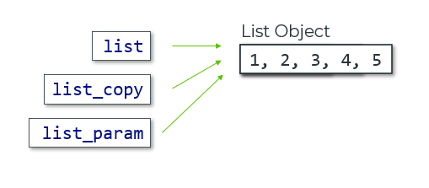

Overview
Type Hints are an optional Python syntax
Integrate really well with IDE intellisense
Strongly recommended for large projects
variable: data_type = value of that data type
Use Cases
They are hints, e.g. suggestions:
What types of values a function expects
What operations a value supports
What value a function will return
IDEs will suggest what methods you can use
The alternative would be to memorize the whole project
Or constantly switch between files to double check that the code is valid
Even then, a typo in a method/attribute name will cause a runtime error
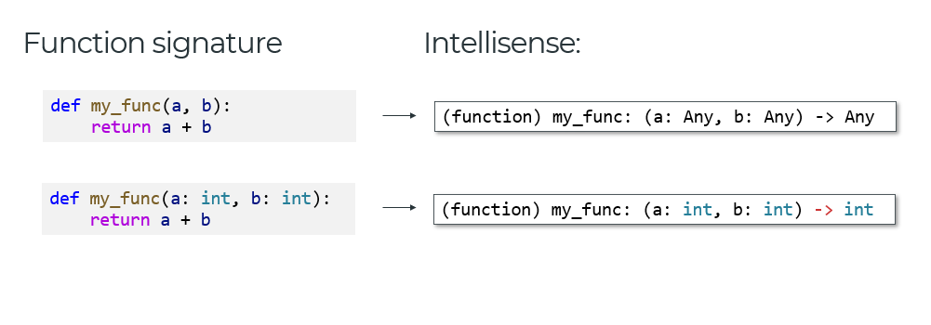
Type Hinting Complex Types
In most cases, IDEs can infer what type of value is returned
def my_func(a: int, b: int):
return a + b
# (function) my_func: (a: int, b: int) -> int
We can also be explicit when required
def my_func(a: int, b: float) -> int:
def another_func(a: str, b: bool) -> str:
def third_func(a: int, b: str) -> list[str]:

dict[str, int] -> dictionary with string keys and integer values
val: str | None -> a value is either a string, or doesn't exist

